**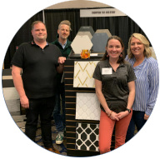******­­­­

**Innovation  
FROM THE FLOOR UP**

**WEDNESDAY, MARCH 8, 2023**

**Bellevue Hilton | 300 112th Ave SE | Bellevue**

**Show Hours: 11:00 a.m. – 7:00 p.m.**

**Happy Hour/No Host Bar: 3:00 p.m. – 7:00 p.m.**

**FREE ADMISSION**

**& PARKING**